# COMP3500: OS Overview – Exercises

**🟊: >85%, 🟊🟊: 70-85%, 🟊🟊🟊: 55-70%, 🟊🟊🟊🟊: 40-55%, 🟊🟊🟊🟊🟊: < 40%**

**🟊Exercise 1 (Plickers):** Which one of the following item is NOT an operating system goal?

* 1. Execute user programs and make solving user problems easier
  2. Make the computer system convenient to use
  3. Improve CPU clock rate
  4. Use the computer hardware in an efficient manner

**🟊Exercise 2 (Plickers):** Choose one item below that end users **don’t** want from operating systems.

(A) Convenience

(B) Ease of use

(C) Short response time

(D) Fast throughput

**🟊🟊 Exercise 3 (Plickers):** Choose one item below that is the least important objective of operating systems supporting batch-processing mainframes (i.e., supercomputers).

(A) Resource utilization

(B) Short response time

(C) Fast throughput

(D) Cooling cost

**🟊🟊🟊🟊Exercise 4:** How to reduce the long system setup time of a serial processing system? (Please use one short sentence to describe your solution.)

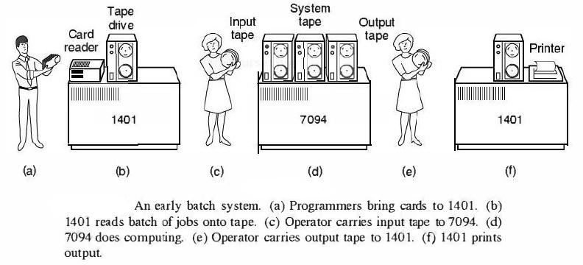

**🟊🟊🟊🟊🟊 Exercise 5 (Plickers):** Which statement about simple batch systems is correct?

(A) Highly inefficient

(B) Over utilized CPU time

(C) Deliver high throughput

(D) Offer interactivity of users

**🟊 Exercise 6:**

If there are *n* users actively requesting service at one time, each user will only see on the average *1/ n* of the effective computer capacity, not counting OS overhead.   
  
Why the response time on a time-sharing system can be similar to that on a dedicated computer?

**🟊 Exercise 7 (New) – Reflective Writing:** What is the most important operating system concept I learned today?